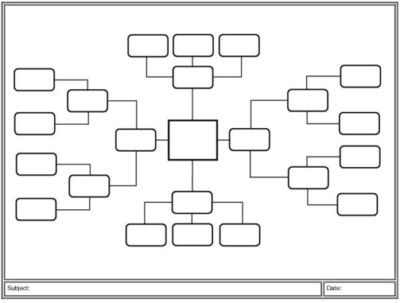

I’m good at

I’d like help with

I’d like to work on

Myself as a

Scientist

Qualities/

Characteristics of a Good Scientist